**Team 10 – Instacart Market Basket Analysis and Recommendation System using Azure Cosmos DB Multi Model Database**

**TEAM MEMBERS:**

|  |  |  |  |
| --- | --- | --- | --- |
| • | Name - Shashank Dongre | NUID - 002747740 | Email - dongre.s@northeastern.edu |
| • | Name - Ashwini Khedkar | NUID - 002738717 | Email – khedkar.as@northeastern.edu |
| • | Name - Keerthanaa Kannan | NUID - 001593845 | Email - kannan.ke@northeastern.edu |
| • | Name - Samradni Pathari | NUID – 002655149 | Email - pathari.s@northeastern.edu |

**INTRODUCTION:**

Instacart is a popular grocery delivery service that offers customers a convenient way to shop for groceries from the comfort of their own homes. With the growing demand for online shopping, Instacart is continually looking for ways to enhance their customer experience. In this project, we propose the development of an Instacart Product Recommendation System using Azure Cosmos DB, a globally distributed, multi-model database service.

Instacart, a popular online groceries delivery service, is operational in 5500+ cities in USA and Canada with 600+ partners serving 9.6 million users, as of 2023. In this project, we propose the development of an Instacart Market Basket Analysis and Recommendation System using a globally distributed, Multi-model NoSQL Database System Azure Cosmos DB. This system will analyze customer purchase history and recommend products based on their purchase history and suggest similar preferences. Here, we are aiming to leverage the multi-model nature of Azure Cosmos DB and explore its graph functionalities to gain insights on relationships between products, and their location.

This system will analyze customer purchase history and recommend products based on their preferences. We will also perform an analysis of the recommendation system to evaluate its effectiveness and identify potential areas for improvement. With this project, we aim to provide a more personalized and enjoyable shopping experience for Instacart customers while improving business efficiency and increasing revenue.

**OBJECTIVES:**

* Representing orders and prior orders as a document database to improve recommendation accuracy.
* Using a document-graph hybrid model to analyse and visualize relationships between customers and the products they ordered, visualize the location of products that are more likely to be reordered.
* Analyzing the details, frequency, and customer preferences of the most frequently ordered products.
* The goal of the project is to understand, design, develop, and implement ETL pipelines to understand the internal working of the data workflows.
* Understand and utilize a host of services provided by the Azure platform and emulate its functioning in a test environment.

**ENTITY RELATIONSHIP DIAGRAM:**

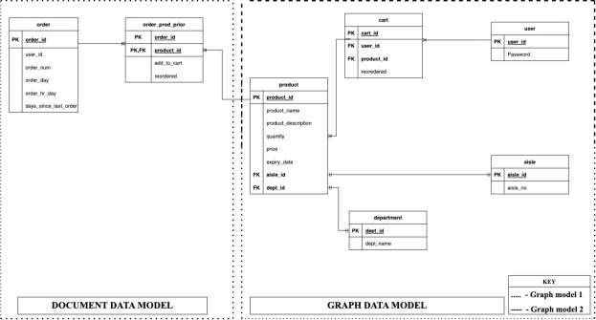

**GRAPH DATA MODEL:**

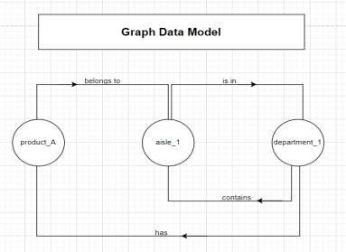

**ENTITY RELATIONSHIP DIAGRAM AND GRAPH DATA MODEL EXPLANATION:**

Our ERD comprises of two sections, one is for document data model and the other one is for graph data model. Firstly, the document data model comprises of two tables namely order and order_prod_prior. In orders table, we have assigned order_id to be a primary key and passing the same as foreign key to order_prod_prior table. In order_prod_prior table we have set the product_id to be a primary key.

Secondly, the graph data model section is further classified into two sections - Graph model 1 and Graph model 2. Graph model 1 involves the product table, department table and aisle table. In the product table, we get the product_id as a primary key and we are passing it as a foreign key to the order_prod_prior table of the document data model section. Also, we are getting dept_id and aisle_id as a primary key from department and aisle tables respectively and are passing the same as a foreign key to the products table. Moving forward, Graph model 2 involves the product table, cart, and user table. Starting from the users table, we are initially setting the user_id as a primary key and we are passing the same as a foreign key to the cart table. Now in the cart table, cart_id is set as a primary key and gets the foreign key, product_id from the products table which is supposedly the primary key of that table.

**ARCHITECTURE DIAGRAM:**

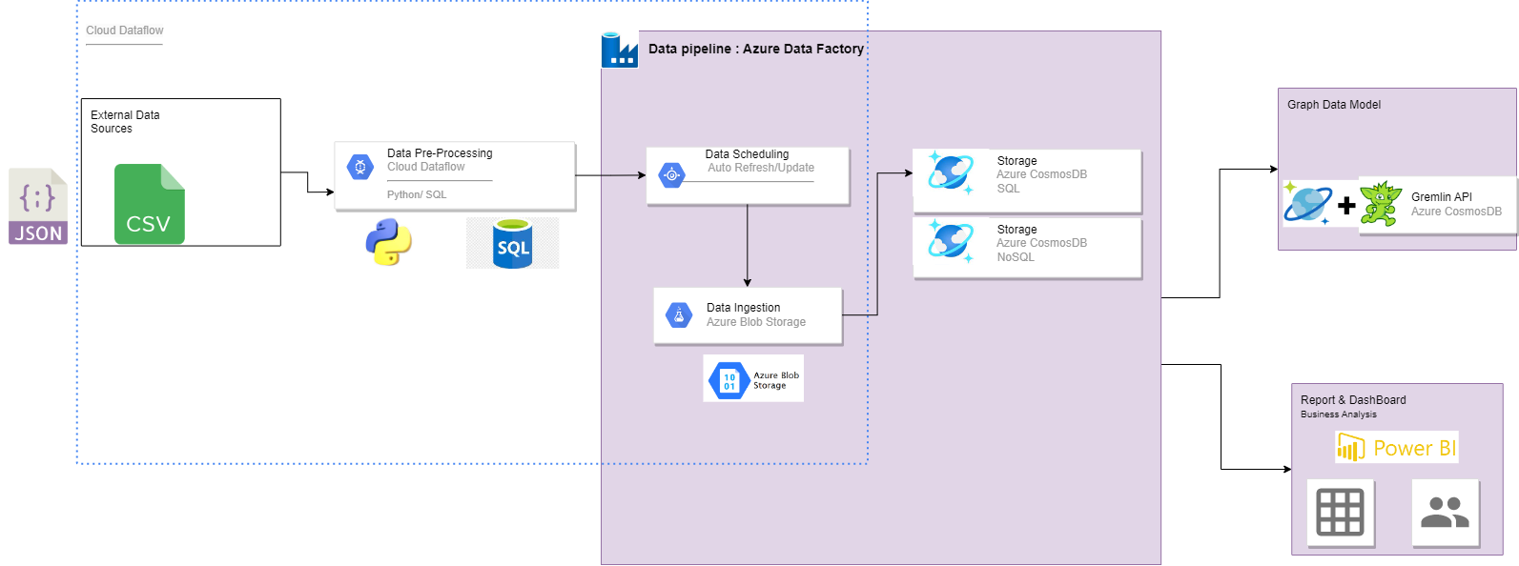

**TECHNOLOGIES/TOOLS USED:**

* Microsoft SQL Server as the database management system.
* Python for data cleaning and pre-processing
* Azure Data Factory for scheduling, data pipeline, and other ETL tasks.
* Azure Blob Storage for object storage solution for the cloud.
* Azure Cosmos DB for multi-model (relational and NoSQL) database service on the cloud.
* Apache Gremlin is the graph traversal language of Apache TinkerPop for Graph modeling.
* Power BI as an interactive data visualization software for reporting and dashboarding.
* Microsoft Excel and Outlook for project operation/execution.
* Draw.io for data modeling and data architecture design.

**DATA WORKFLOW:**

* Source of data is online from the Kaggle, an online community of data scientists and data repositories.
* Data cleaning and Pre-processing is to be done using Pandas library of Python Programming language.
* Data is then exported to SQL Server in a flat file format (e.g., CSV or JSON).
* Initial Data modeling is to be performed on the dataset locally.
* Data is then exported to Azure Blob Storage using Azure Portal, Azure Storage Explorer, or Azure CLI.
* Data is moved from Blob storage to Azure Cosmos DB by creating a data Pipeline in Azure Data Factory.
* Trigger is run to regularly ingest data into Azure Cosmos DB.
* Graph data is then pushed to Apache TinkerPop Gremlin API to be used for graph data model implementation.

**FUTURE SCOPE:**

* Integration: Integration of Document and Graph Data Models: Using Azure Synapse (exploring other options as well)
* Machine Learning: Using dedicated SQL Pools to store, train, and test data to build ML models for better recommendations.
* Deployment: Model can be deployed in Azure Machine Learning as a web service which can be called using REST APIs.
* Application: A mobile app or web app can be built for such large-scale product recommendation and customer analysis
* Since the model is scalable and available, the data pipeline and Azure data workflows could be more optimized as the number of users grow to millions of millions of users.

**IMPLEMENTATION STEPS:**

**GRAPH IMPLEMENTATION STEPS FOR P3:**

* Set up an Azure Cosmos DB account: The guide provides detailed instructions on how to create an Azure account and a Cosmos DB account.
* Create a graph database: You will create a graph database with a sample dataset using the Azure Portal or the Azure CLI.
* Install Python and the Gremlin library: The guide provides instructions on how to install Python and the Gremlin library.
* Connect to the graph database: You will create a connection to the graph database using the endpoint, database name, and authentication key.
* Write Gremlin queries: The guide provides examples of Gremlin queries to create vertices, edges, and traverse the graph.
* Run Gremlin queries: You will use the Python script to execute the Gremlin queries and interact with the graph database.

**DOCUMENT IMPLEMENTATION STEPS FOR P3:**

* Configure the Azure Blob storage linked service. In the Azure Data Factory pipeline, you will need to create a linked service to Azure Blob storage. You will need to specify the storage account name and access key, and the container name where the exported data files are stored.
* To create a dataset for a source data in Azure Blob storage, follow these steps:
* Open the Azure portal and navigate to your Azure Data Factory instance.
* Click on the "Author & Monitor" button to launch the Azure Data Factory user interface.
* Click on the "Author" tab to enter the Data Factory authoring environment.
* Click on the "Create dataset" button to create a new dataset.
* Select "Azure Blob Storage" as the source data store type.
* Specify the connection details for your Azure Blob storage account.
* In the "Select format" section, choose "JSON format" if your source data is in JSON format.
* In the "File path" section, specify the location of the JSON file in your Azure Blob storage account.
* In the "Schema" section, specify the structure of the JSON file.
* Click on the "Preview data" button to preview the data in your JSON file.
* Click on the "Publish all" button to save your changes.
* After creating the dataset, you can use it in your data pipeline as a source data for further processing, such as copying the data to another data store like Azure Cosmos DB.

**AZURE BLOB STORAGE:**

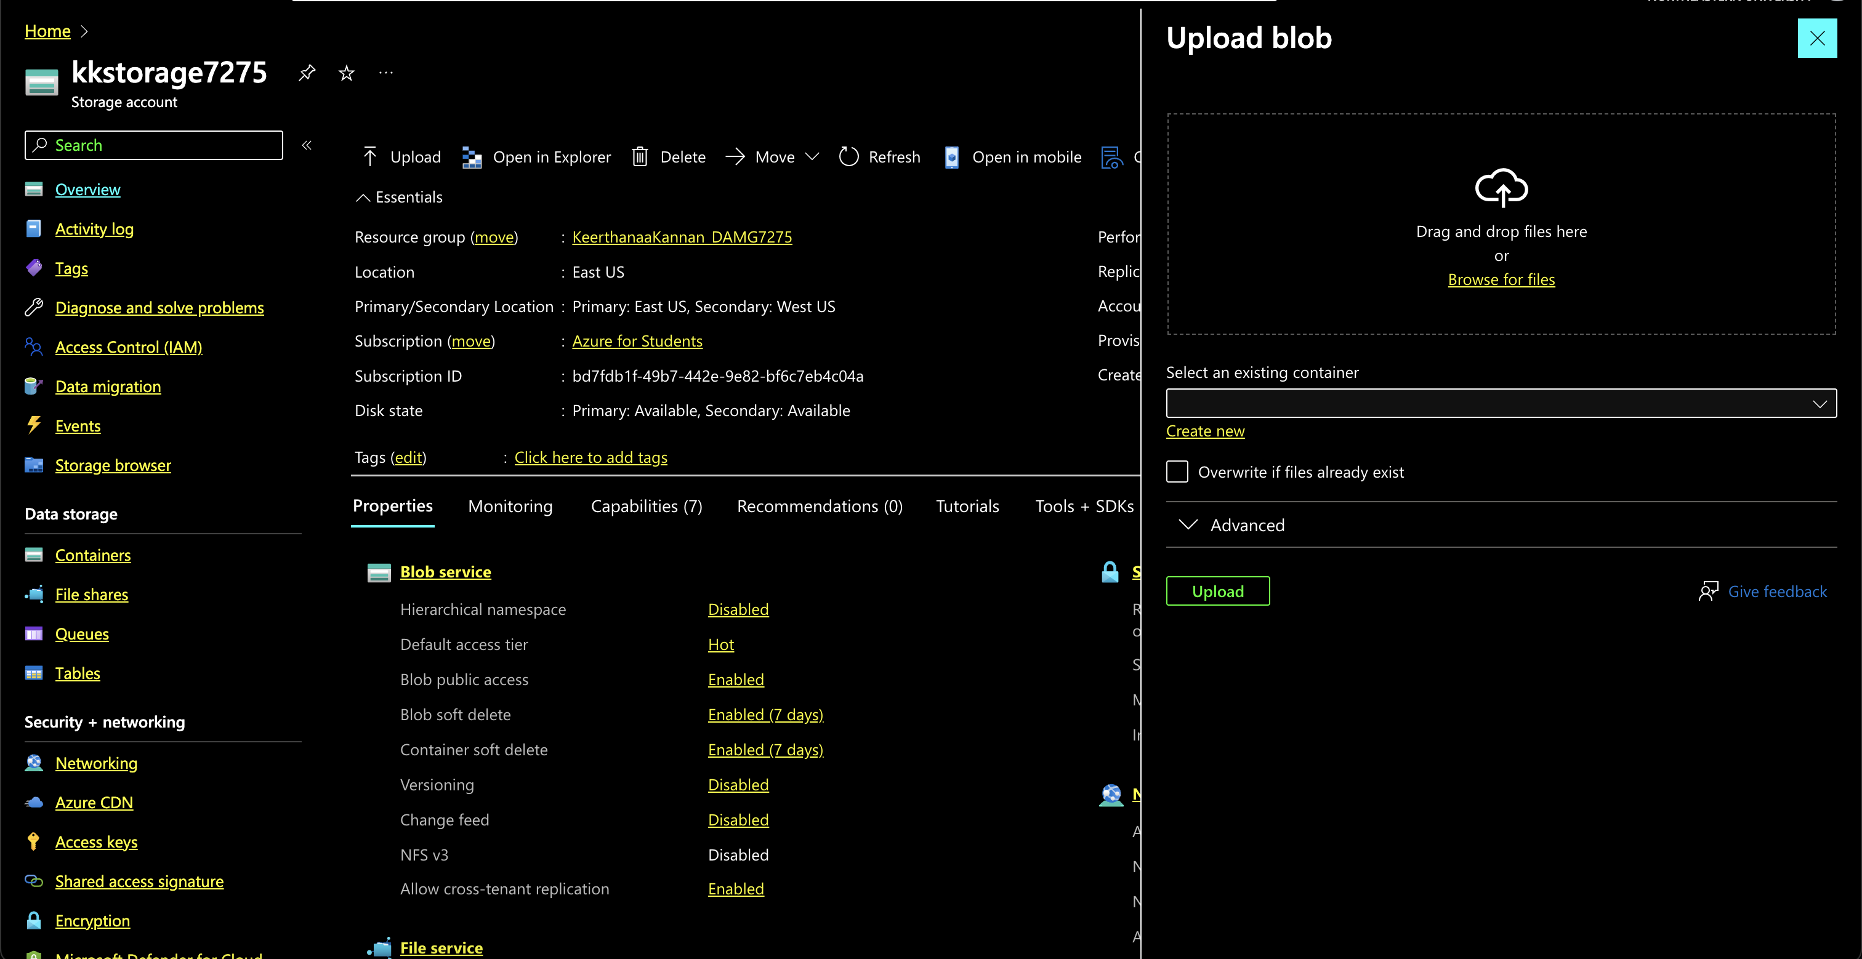

**DOCUMENT IMPLEMENTATION FOR P4 and P5:**

* We continue this step with the creation of required data pipelines. We are using it in our data pipeline as a source data for further processing, such as copying the data to another data store like Azure Cosmos DB. Below screenshot is from the copy data activities. We divided our dataset into two parts:

1. Document data model for upload and copy of the document data which contains orders and order_products_sample from Azure blob storage to Azure Cosmos DB.
2. Graph data model for upload and copy of the Graph data which contains Aisles, Department, and Product data from Azure blob storage to Azure Cosmos DB.

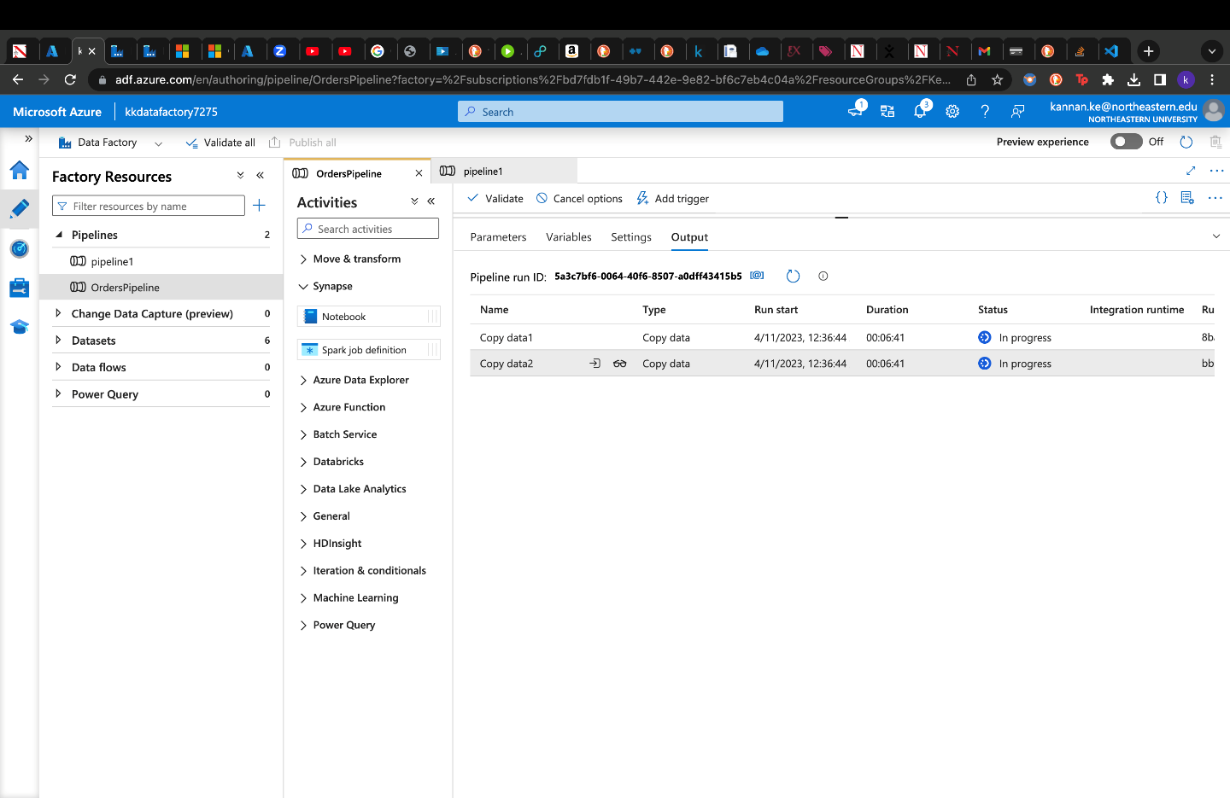

* Below are two screenshots of the successful ingestion of document data into Azure Cosmos DB database from Azure Blob Storage.
* OrderID is selected as partition key, dividing the dataset in countless partitions for faster query performance.

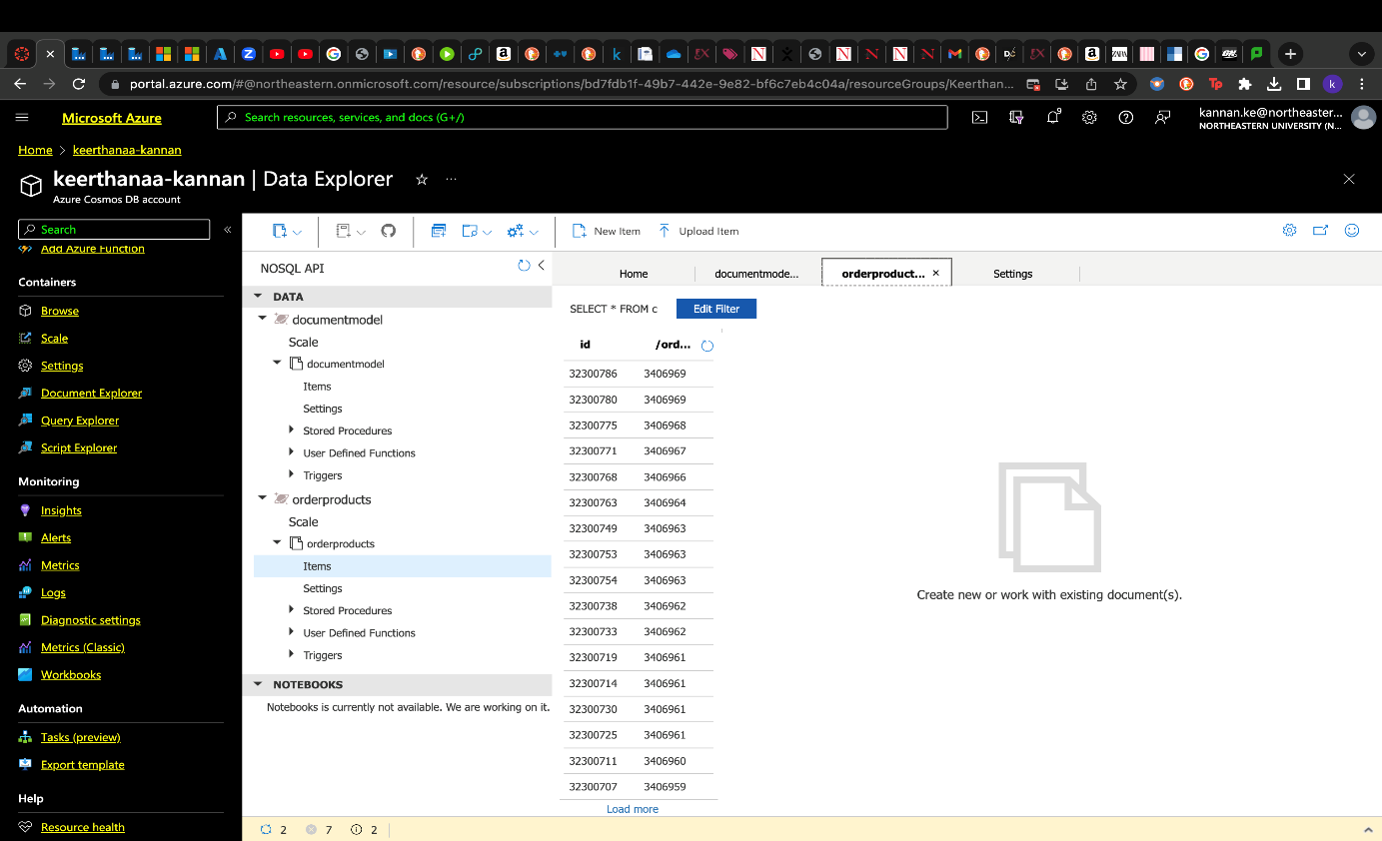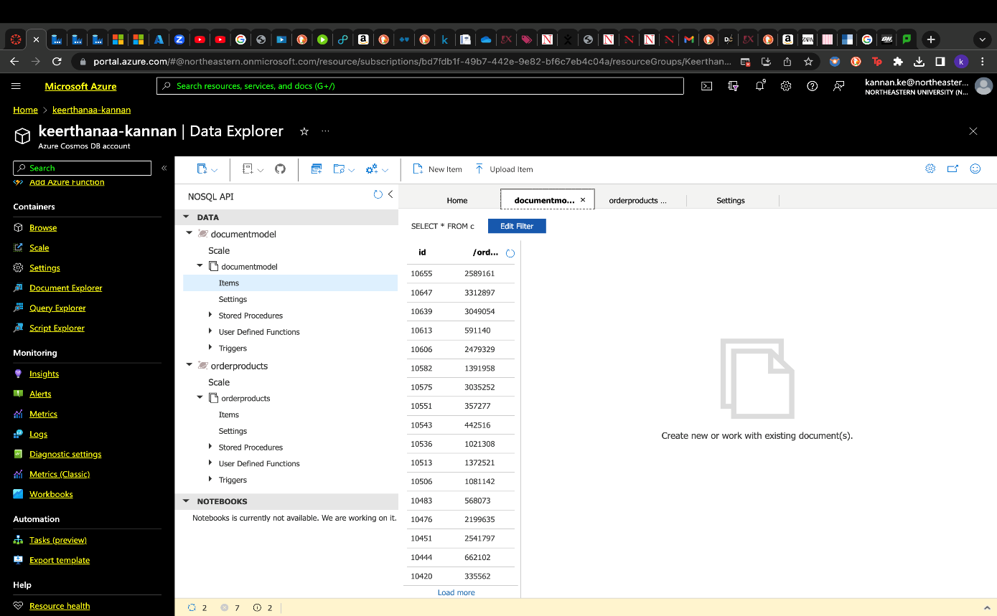

**COMPLETE DATA PIPELINE:**

**Integration and implementation of all data workflow components in the data pipeline.**

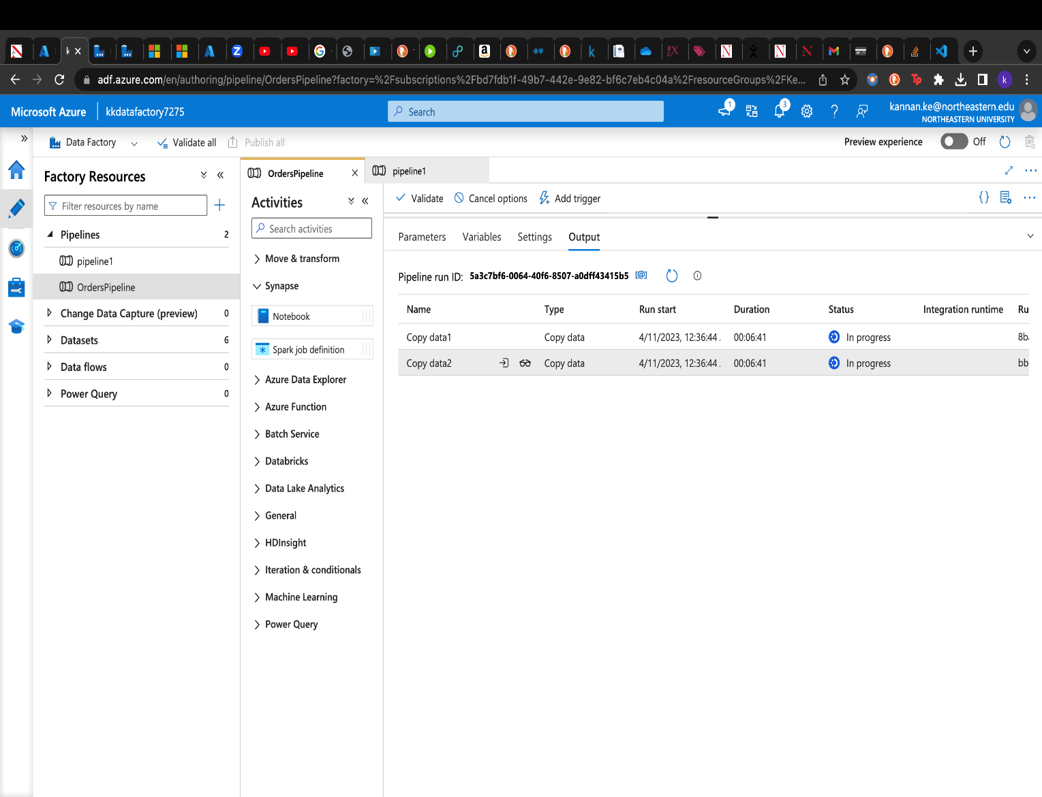

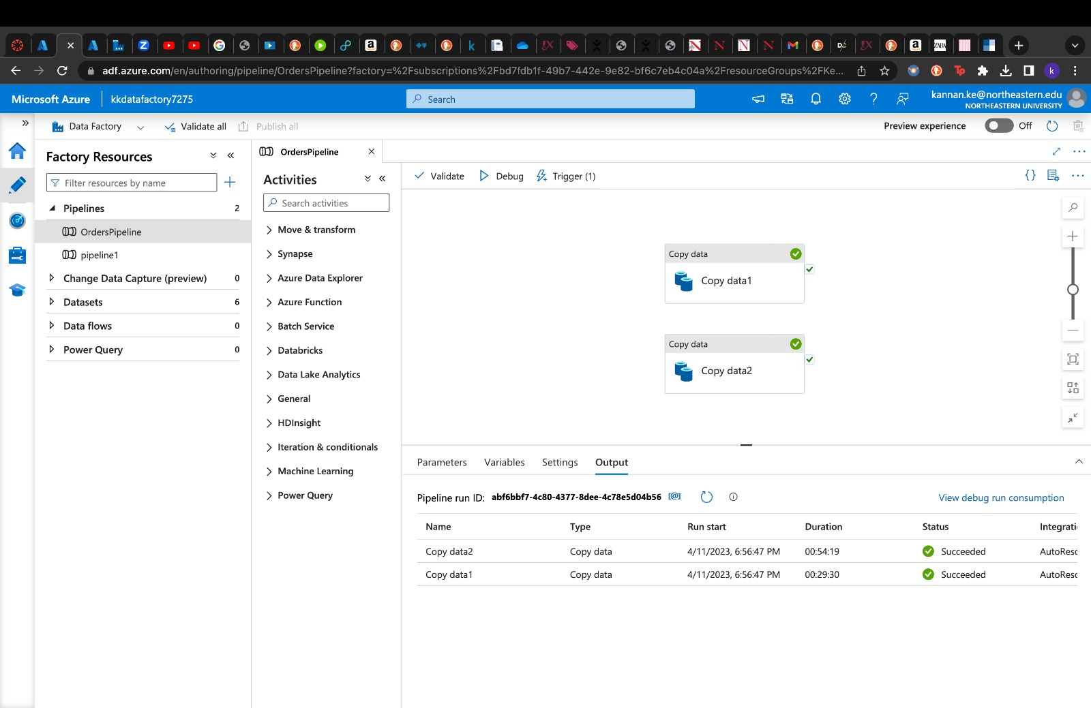

**DATA REFRESH (DOCUMENT):**

**HTTP trigger is used for document data update. The schedule is run every 15 minutes and thus the Cosmos DB document container gets updated with fresh records from the Blob storage.**

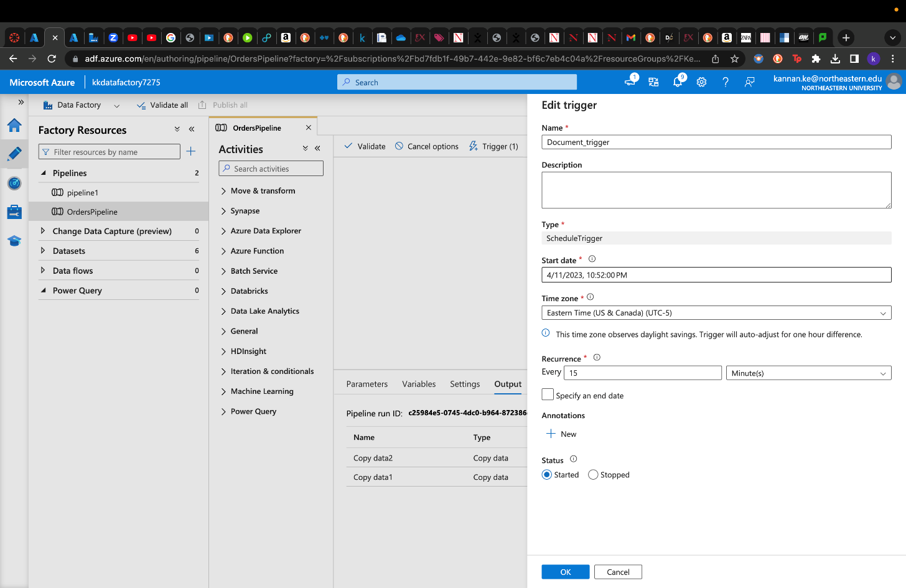

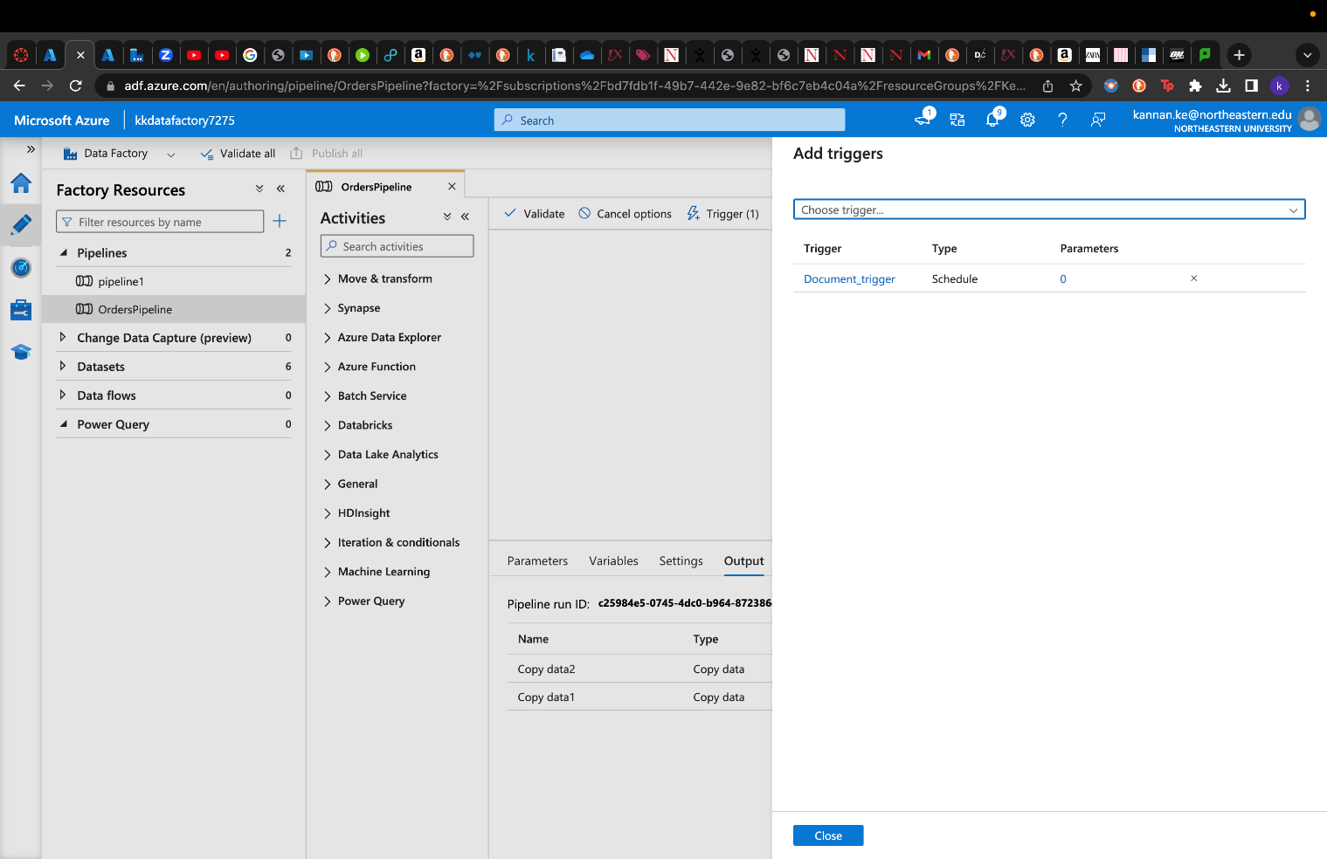

**GRAPH IMPLEMENTATION FOR P4 and P5:**

* We continue this step with the creation of required data pipelines. Graph data model for upload and copy of the Graph data which contains Aisles, Department, and Product data from Azure Blob storage to Azure Cosmos DB.
* We have used a Python Script which connects to the database and contains information, insertion, and function definitions related to all node and edge data.
* The script also contains function definitions like insert_vertices, count_vertices, insert_edges, etc. along with some error handling code.
* Below are few screenshots of the successful ingestion of graph data into Azure Cosmos DB database from Azure Blob Storage.
* Here, aisle_id is selected as the partition key. Here, with just aisle_id, we can obtain information about the department, aisle, and the products the aisle contains in the graphical format.

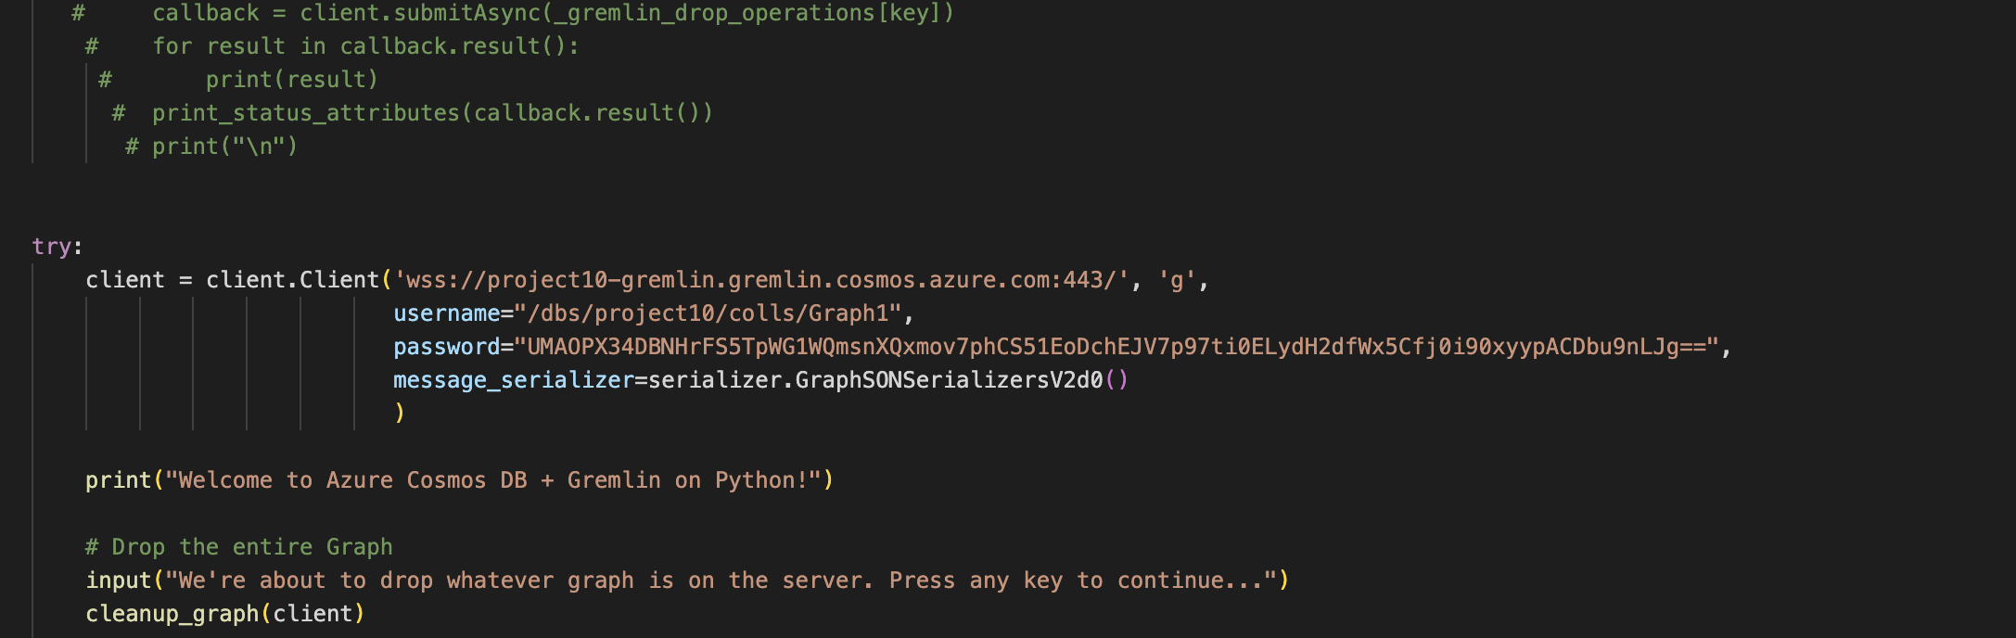

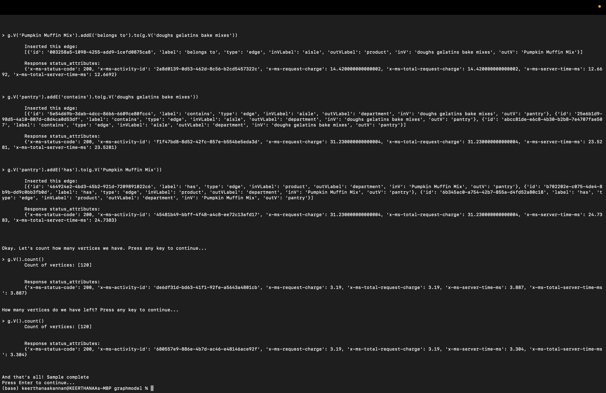

DATA REFRESH (GRAPH):

* We make use of the connect.py python script to kickstart the auto data refresh for graph data model in Gremlin API.
* Graph data refresh function created using Azure Logic Apps integrates our data across cloud services and on-premises systems. The input is Azure Blob Storage, and the output is set to Azure Cosmos DB.
* Below are the few important implementation steps like data refresh for graph data model using Gremlin API.
* We are using Azure Logic Apps for building automated scalable workflows, business processes, and enterprise orchestrations to integrate our data across cloud services and on-premises systems.
* The below screenshots make use of the connect.py python file to kickstart the auto data refresh for graph data model in Gremlin API. The testing and successful connection for the same are captured below.
* The integration of Graph data refresh function created using Azure Logic Apps is successfully tested and integrated in the workflow. The input is Azure Blob Storage, and the output is set to Azure Cosmos DB.

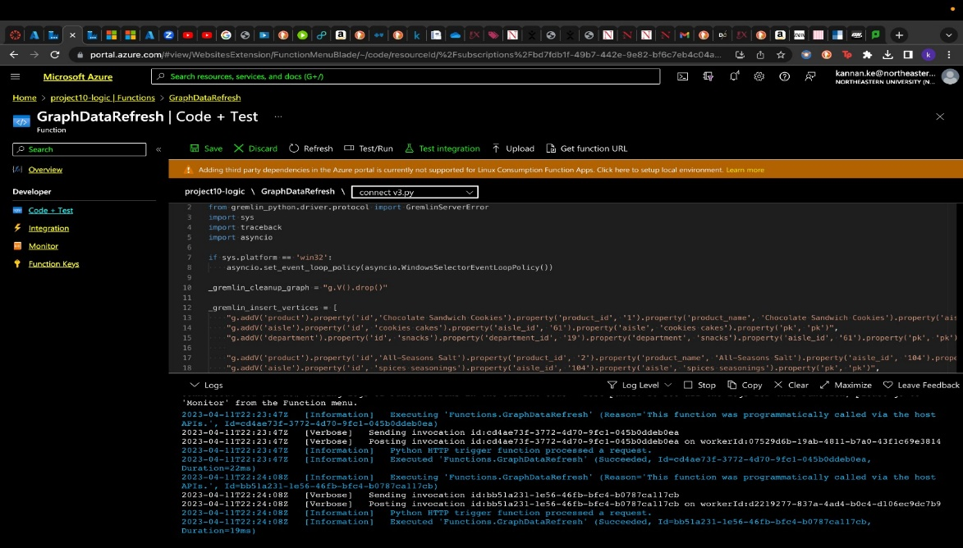

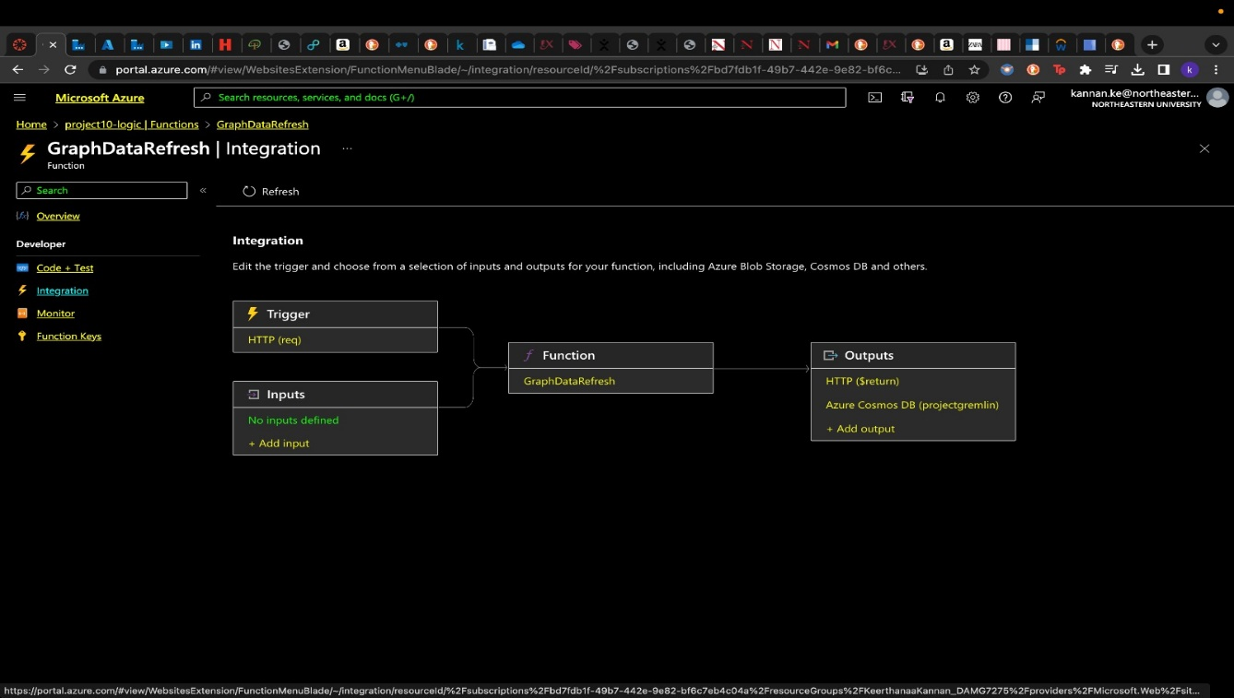

DATA LOADED INTO COSMOS DB GREMLIN API:

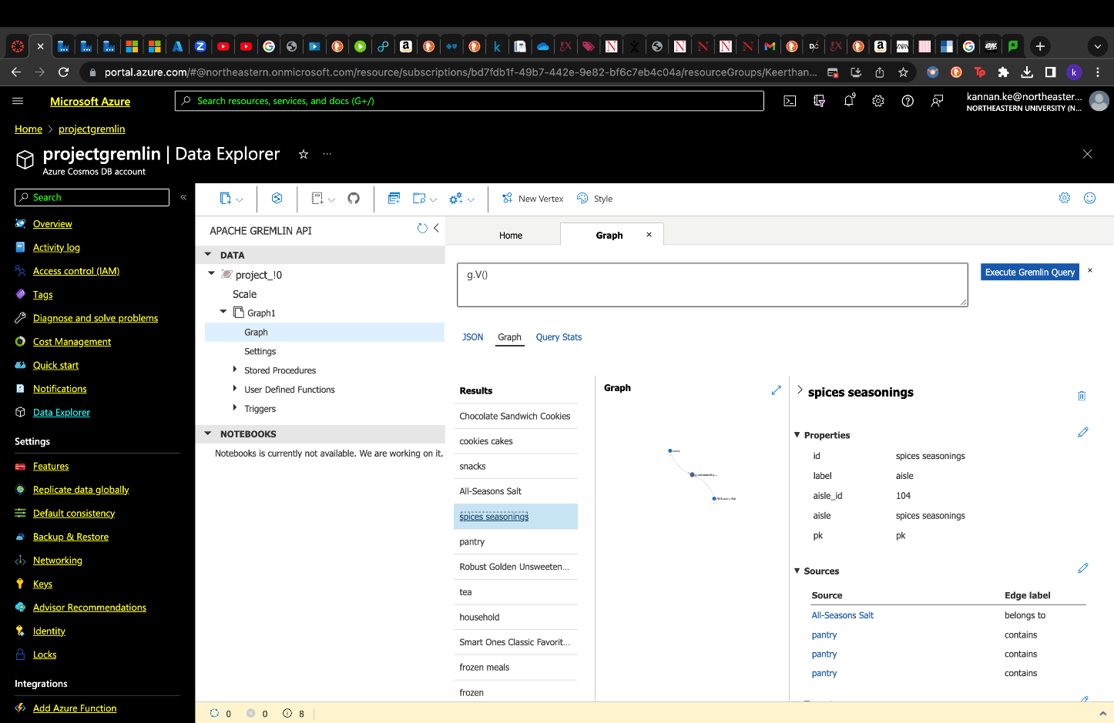

GRAPH DATA VISUALIZATION OVSERVED IN GREMLIN:

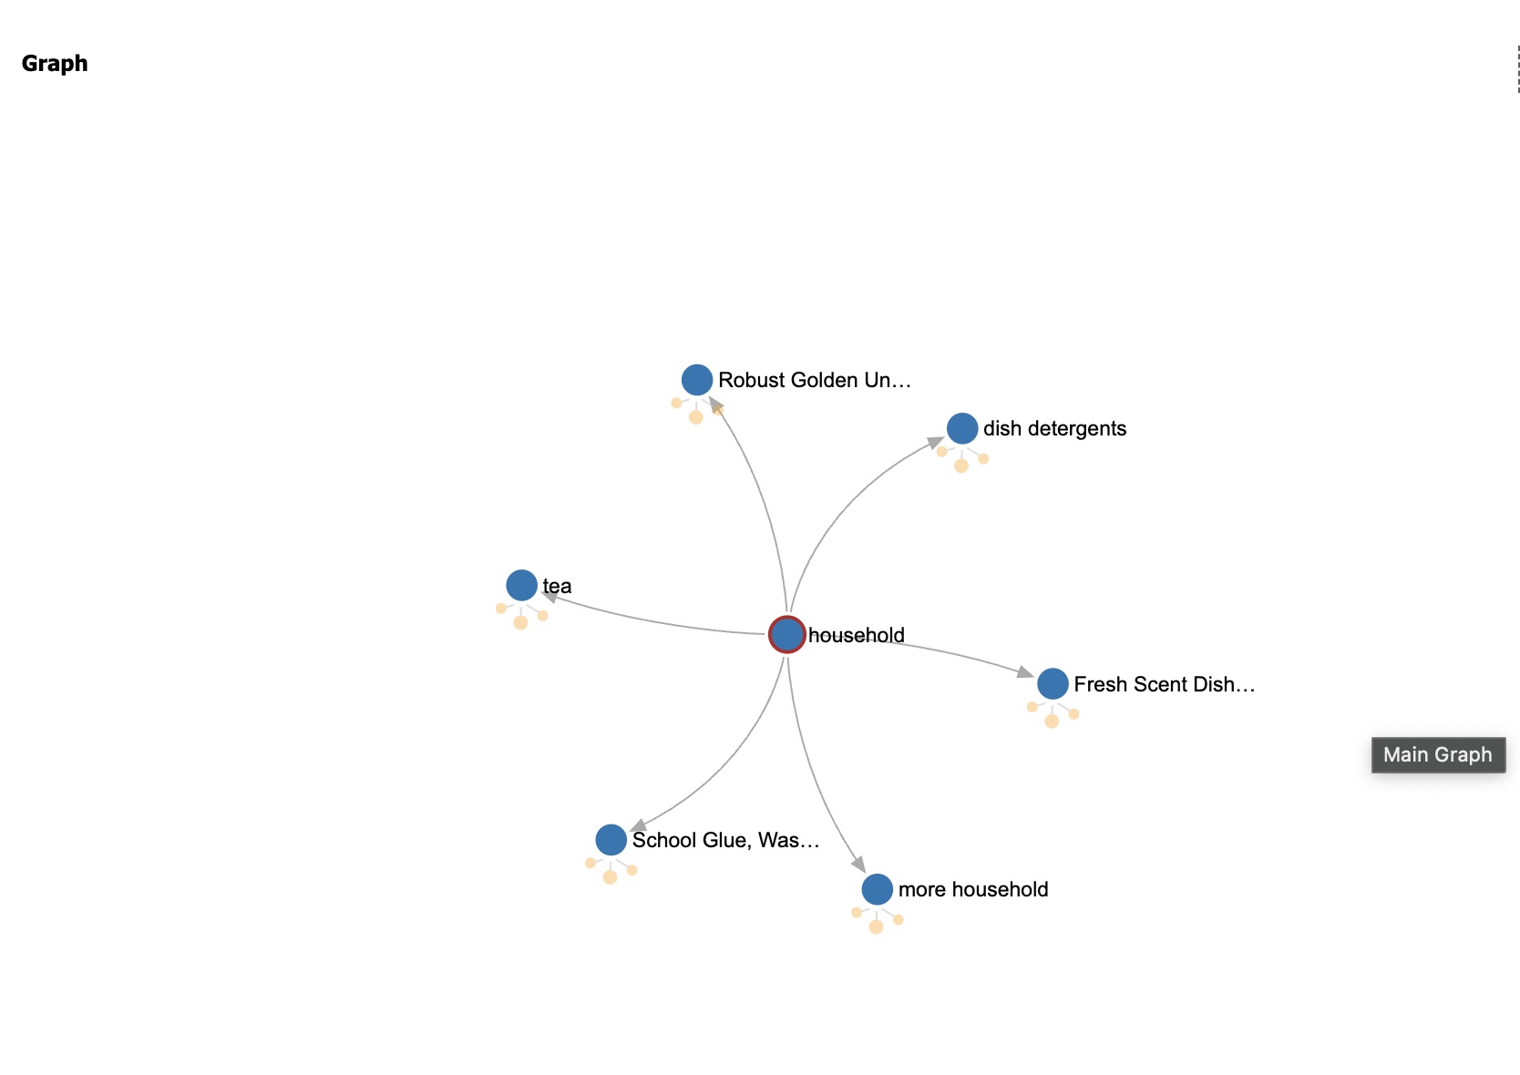

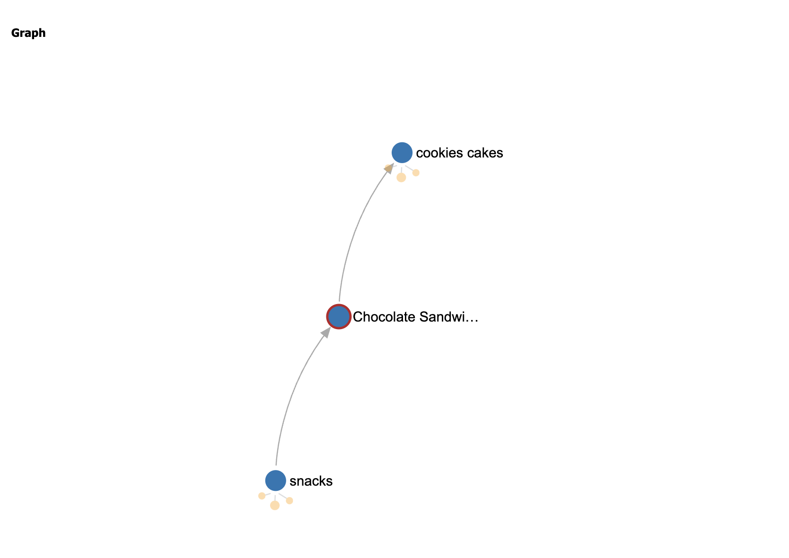

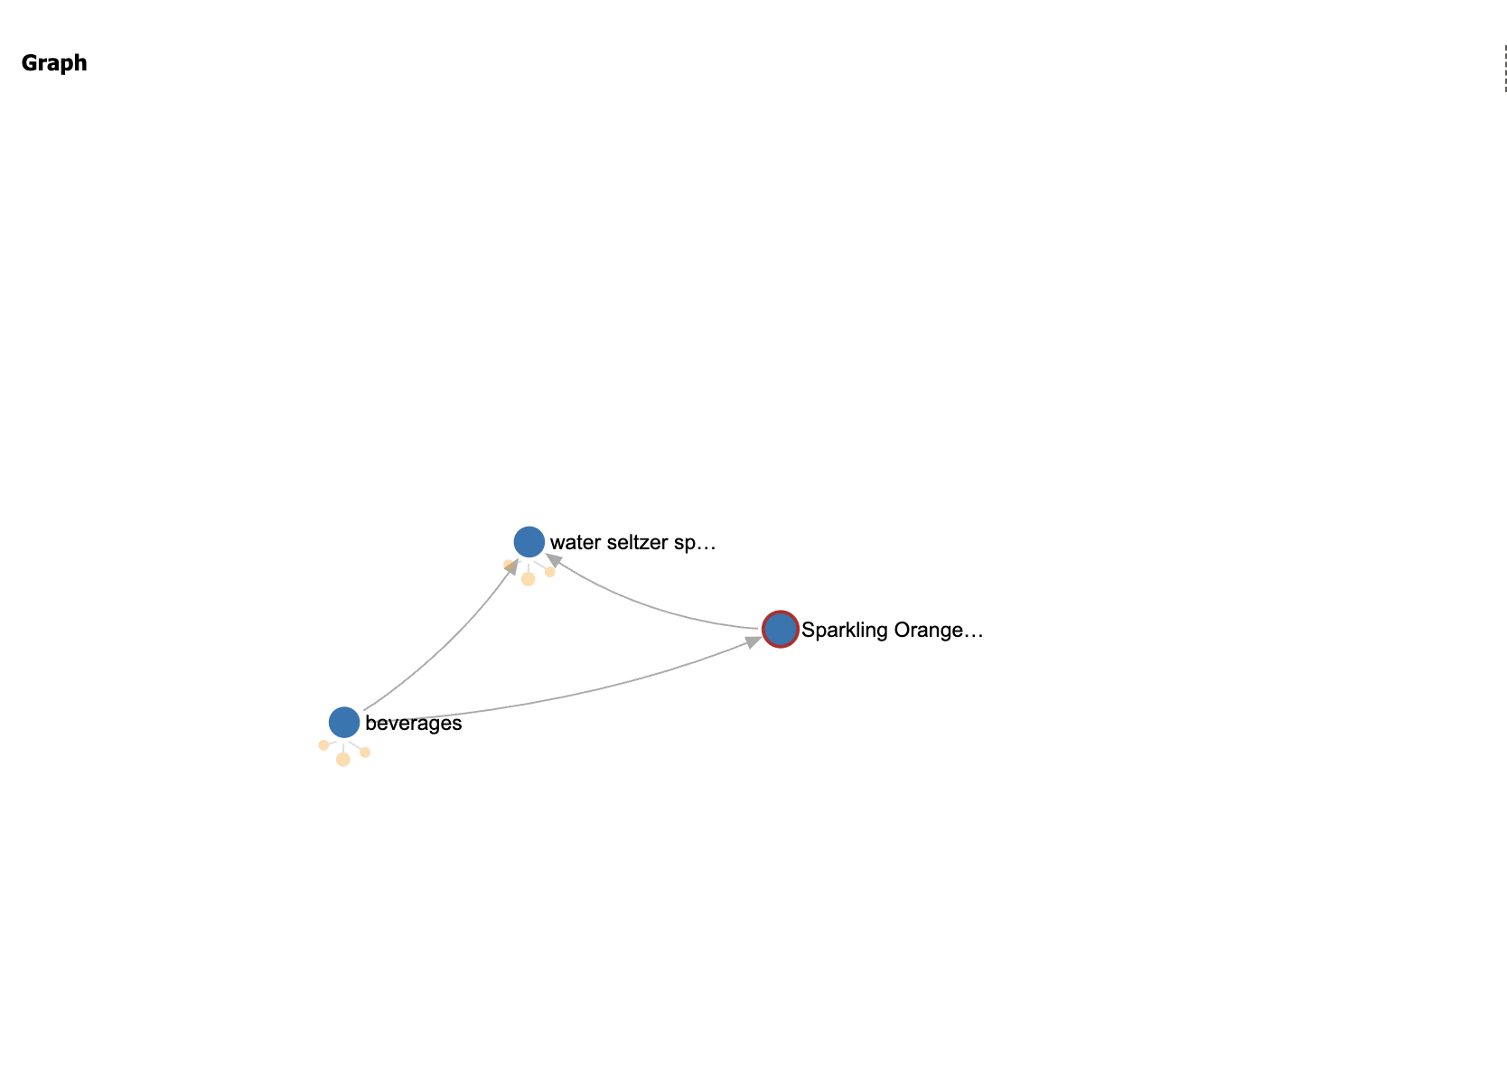

DATA REFRESH CODE TEST (GRAPH):

Code testing for the graph data model was successfully conducted and implemented.

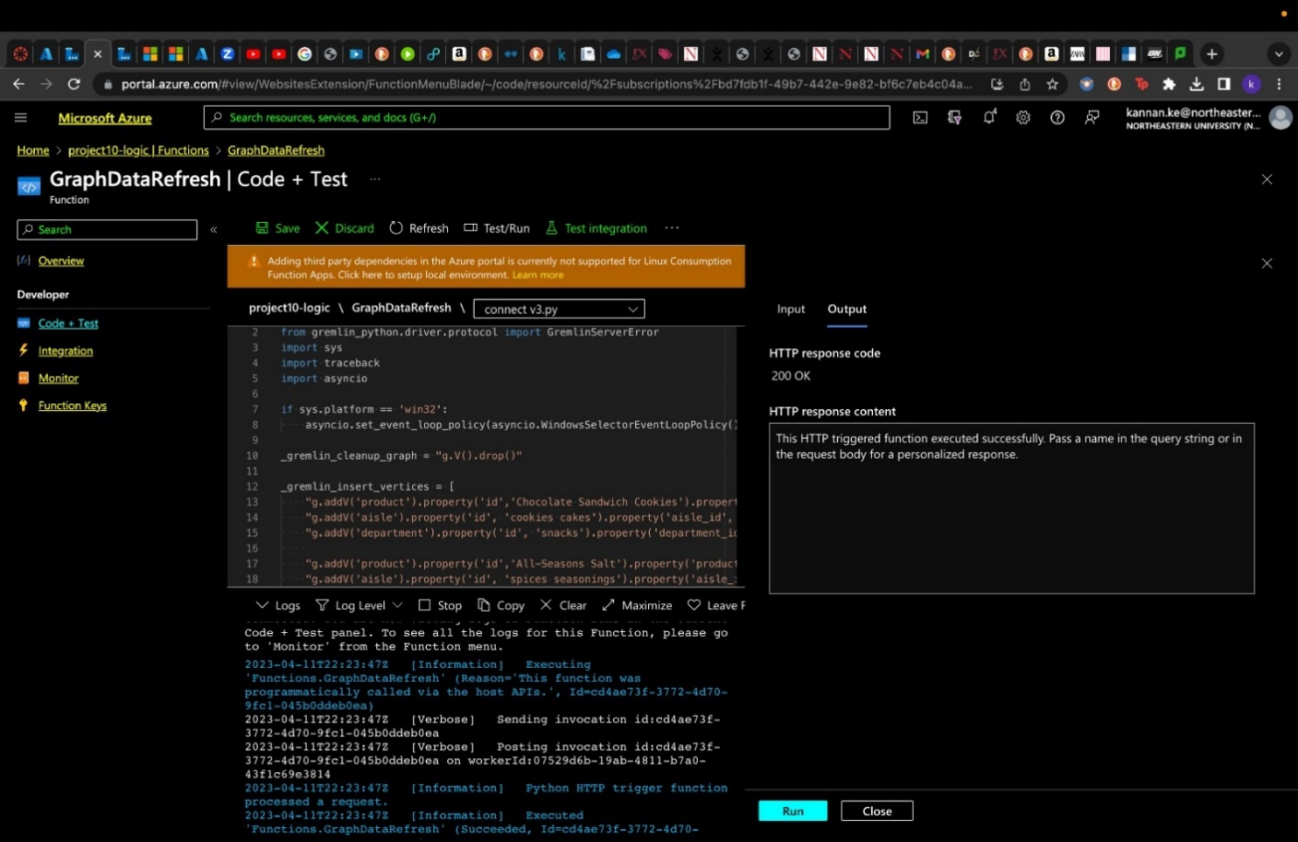

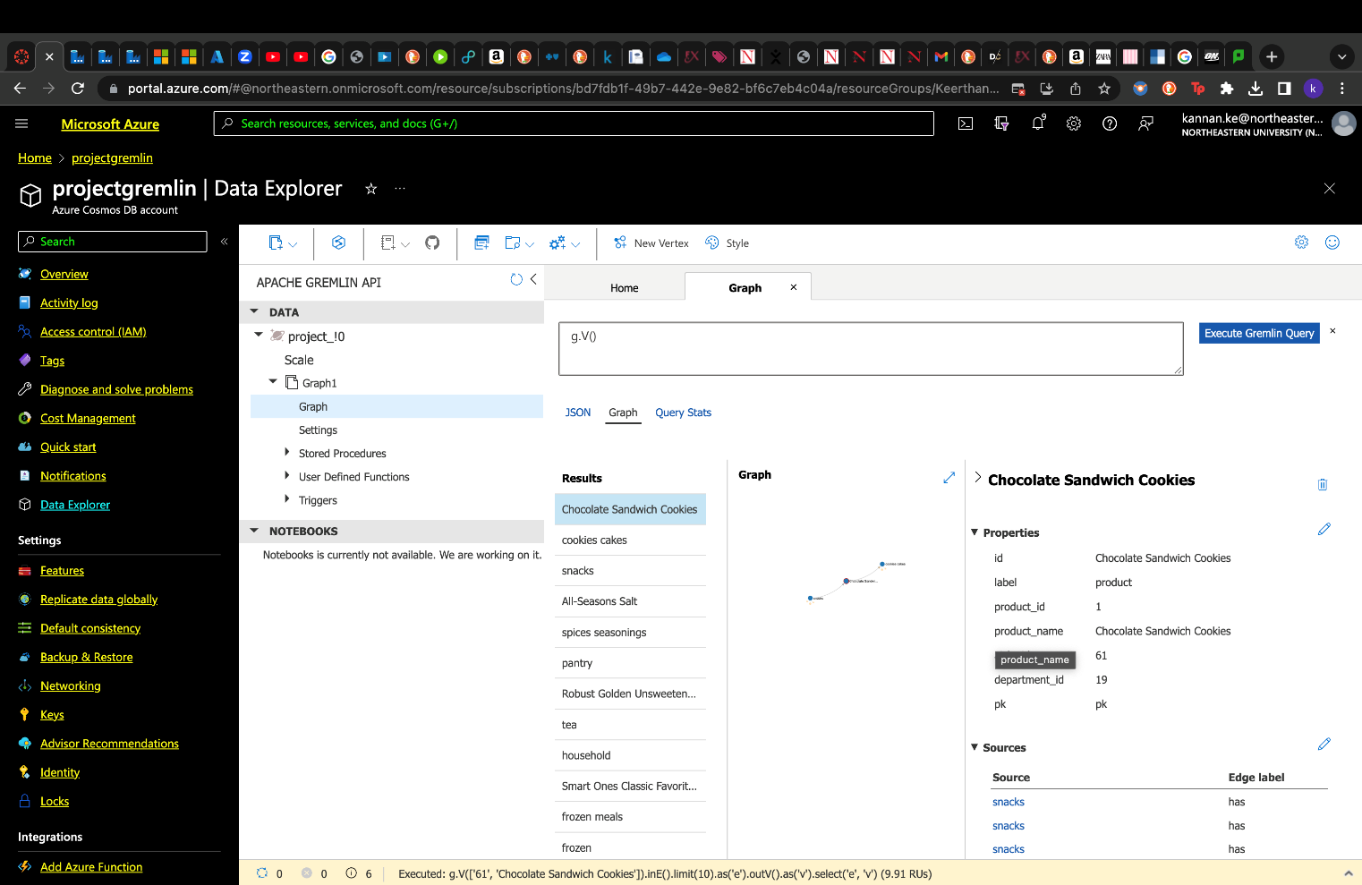



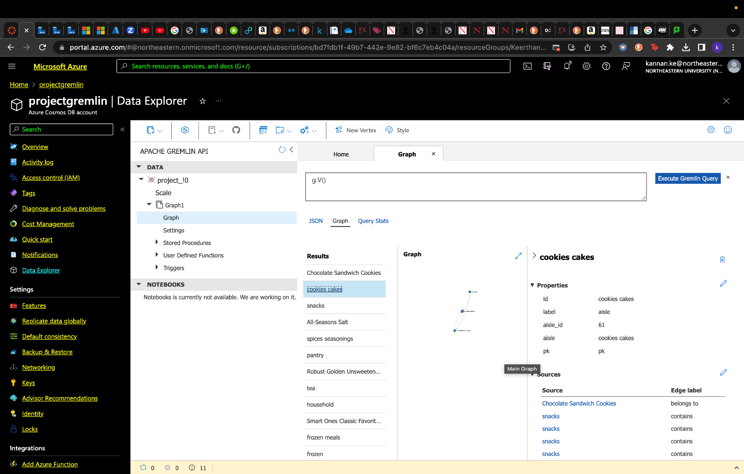

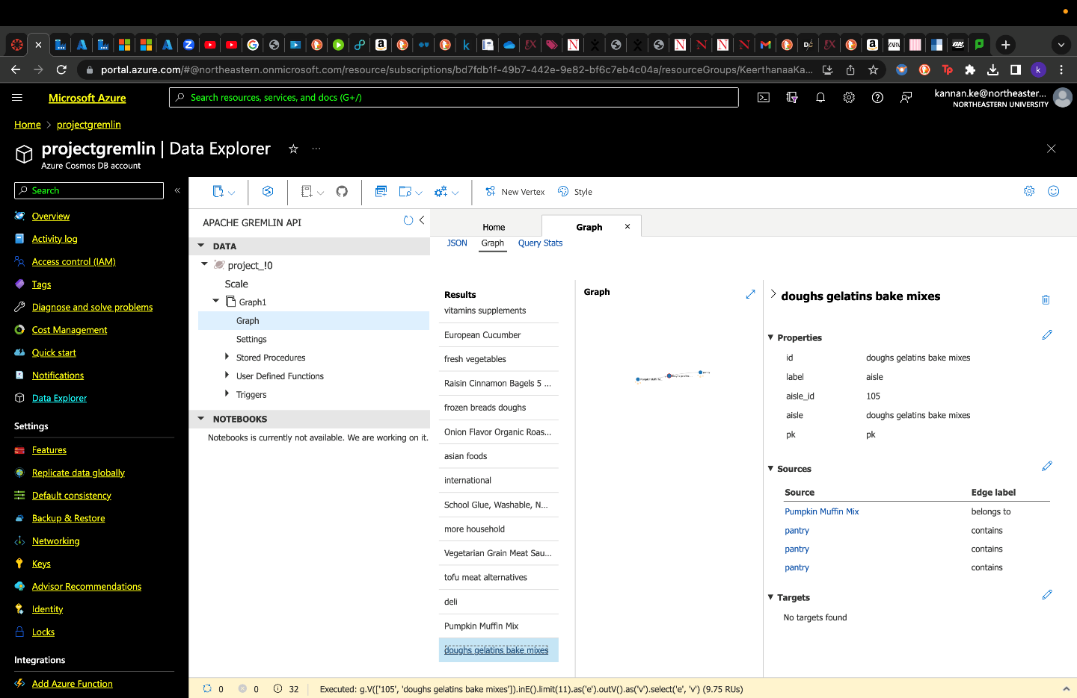

**KEY STEPS CAPTURED FOR DOCUMENT DATA MODEL IMPLEMENTATION:**

* Below are the few key implementation steps captured for better understanding of the working of the data pipelines.
* The screenshot below shows successful connection of the pipelines and other details regarding the Azure resources being utilized for our project.

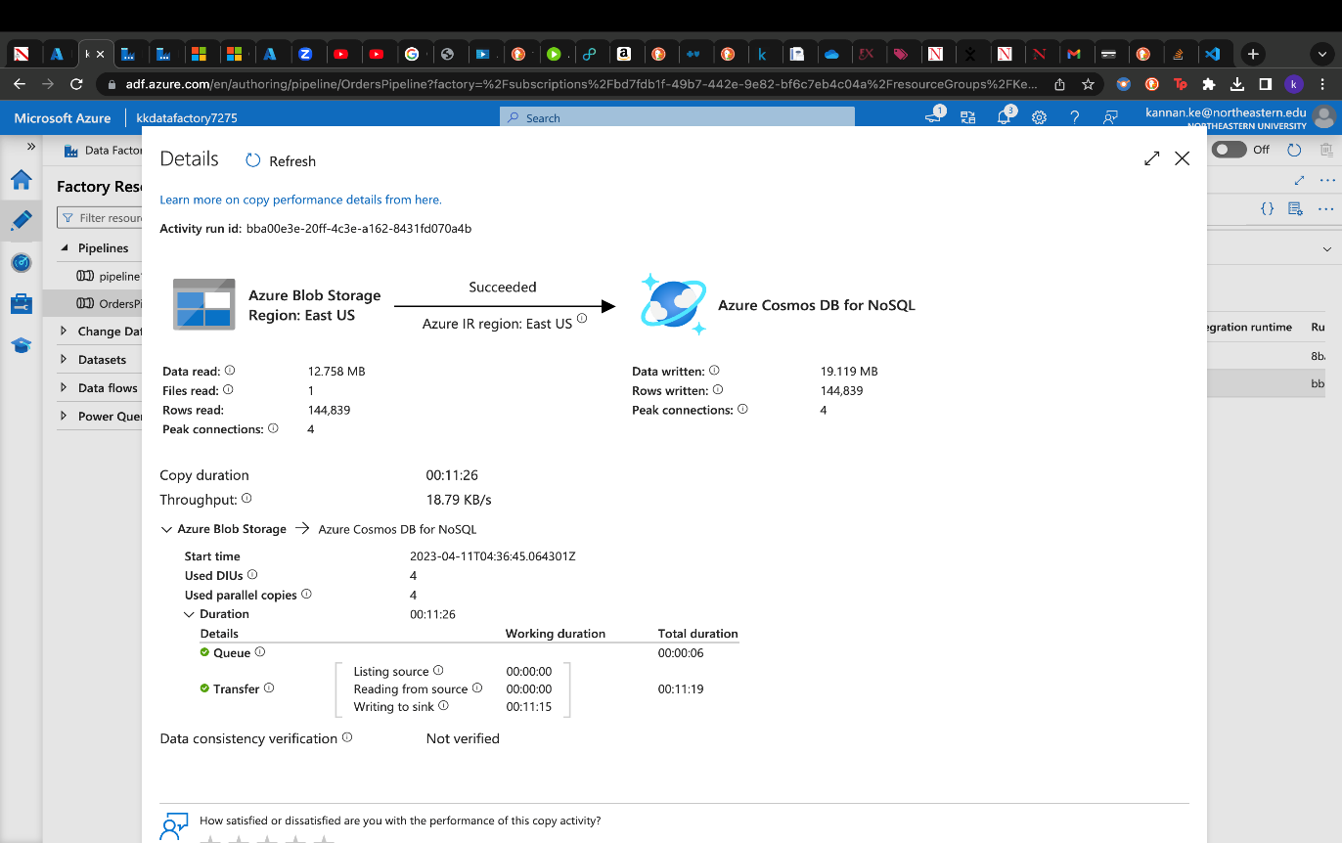



**TRIGGER IMPLEMENTATION CAPTURED FOR DOCUMENT DATA MODEL:**

* Below are the few key implementation steps like addition of triggers for auto data refresh are captured for better understanding of the working of the data pipelines.
* The HTTP trigger for document data update is added as shown below using Azure Data Factory. The schedule is run every 15 minutes and thus the Cosmos DB database gets updated with periodical data updates.
* Azure Functions is the simplest option for using the change feed. Due to its simplicity, it is also the recommended option for most change feed use cases. When we create an Azure Functions trigger for Azure Cosmos DB, we select the container to connect, and the Azure Function gets triggered whenever there is a change in the container. Because Azure Functions uses the change feed processor behind the scenes, it automatically parallelizes change processing across our container's partitions. In this way, change data is captured and updated every 15 minutes.





**RUNNING THE ENTIRE PIPELINE AFTER TRIGGER IMPLEMENTATION:**

* To test the smooth working of the data pipeline after the successful testing of the triggers and other functions, below is a screenshot after running the pipeline post successful implementation.



**VISUALIZATION:**

**Performed Visualizations and generated a dashboard using Power BI**

